**Module 3 Activity 5: Data Access**

Sushmita Prafull Halasawade

IFT 544: Middleware Prog & Database Sec

Dinesh Sthapit

24 Sep 2023

Task1: Reusable components to create composite components.

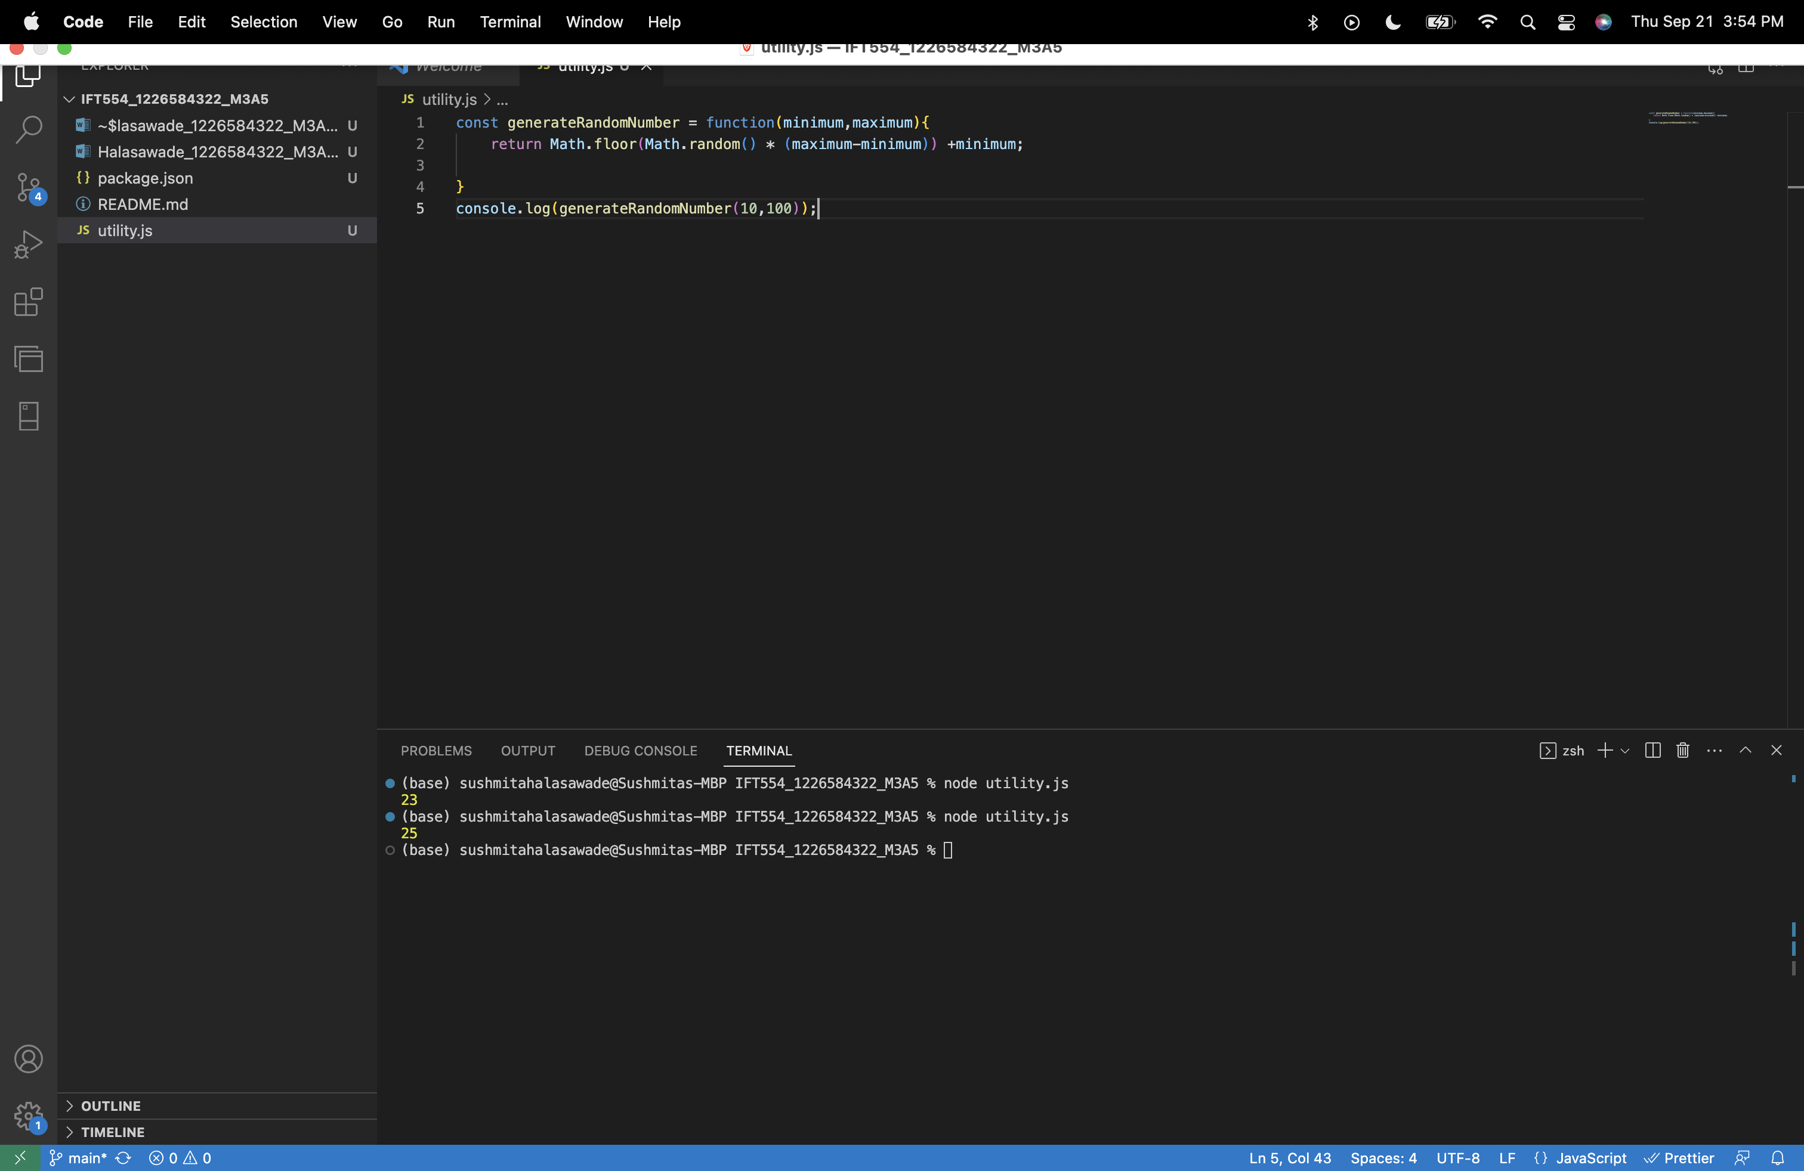

After importing utility.js module in index.js :

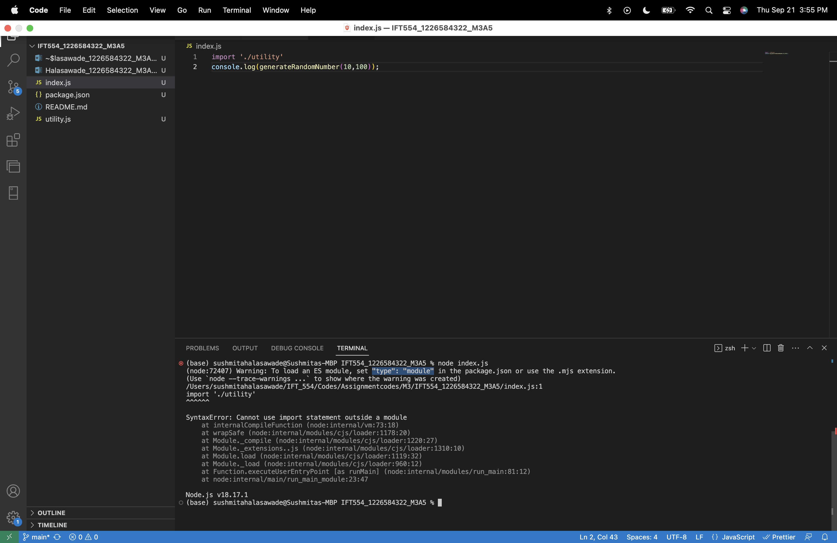

Added type= module in package.json to resolve the issue.

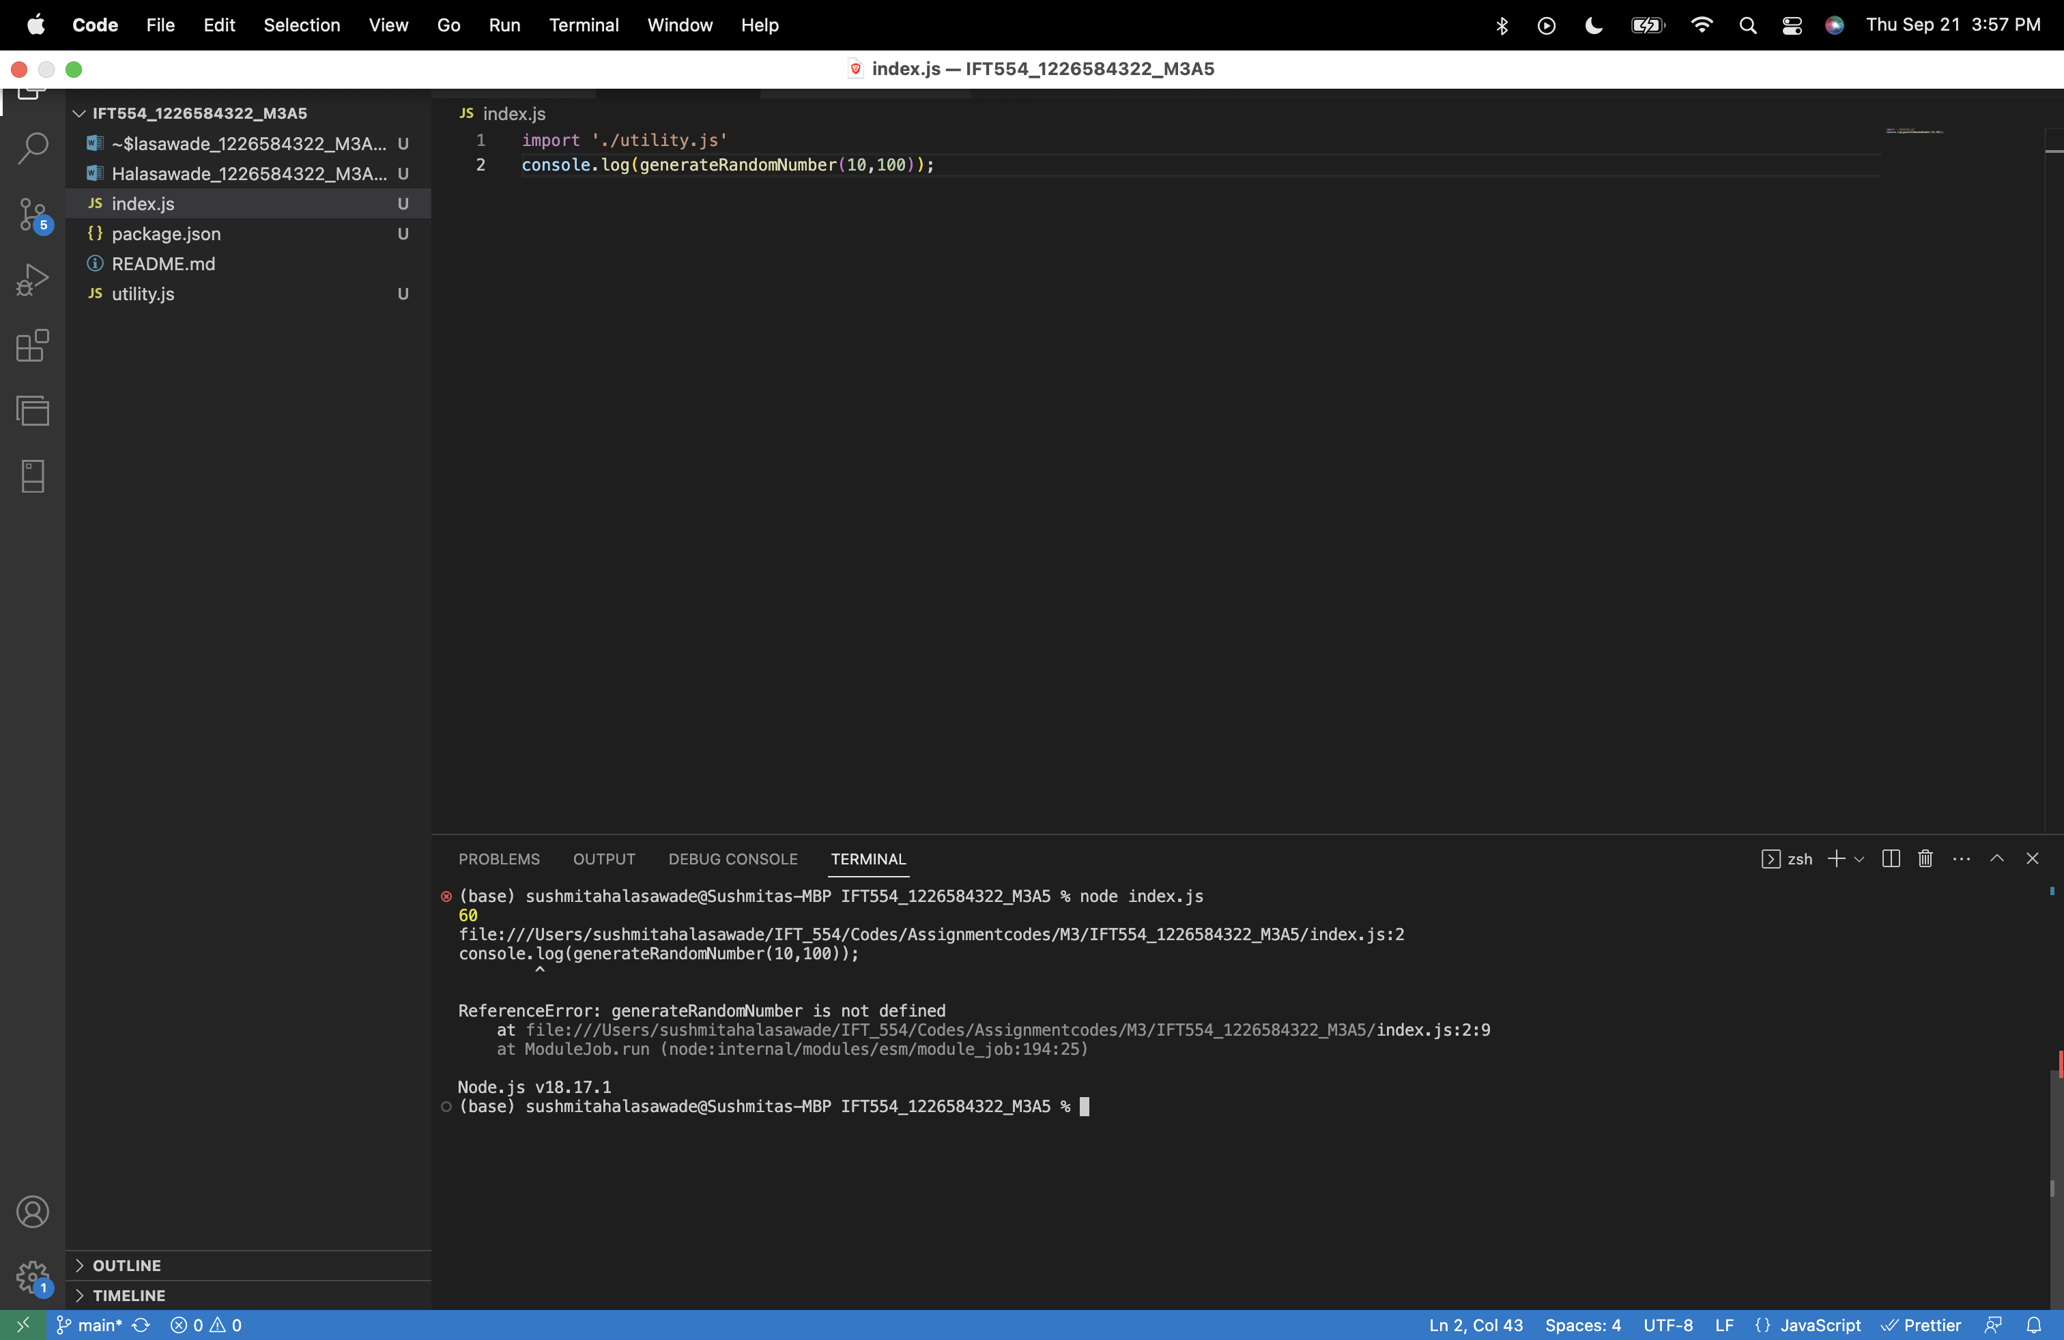

Now getting reference error for the generate random number function , to resolve this we have to add export in utility.js:

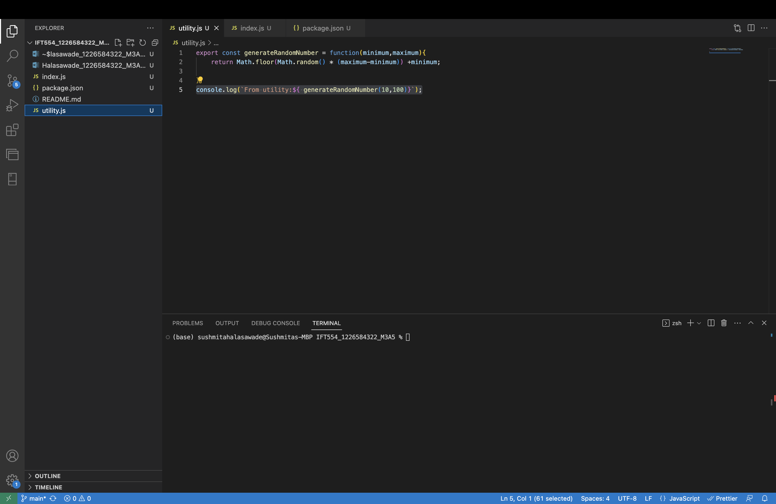

Index.js:

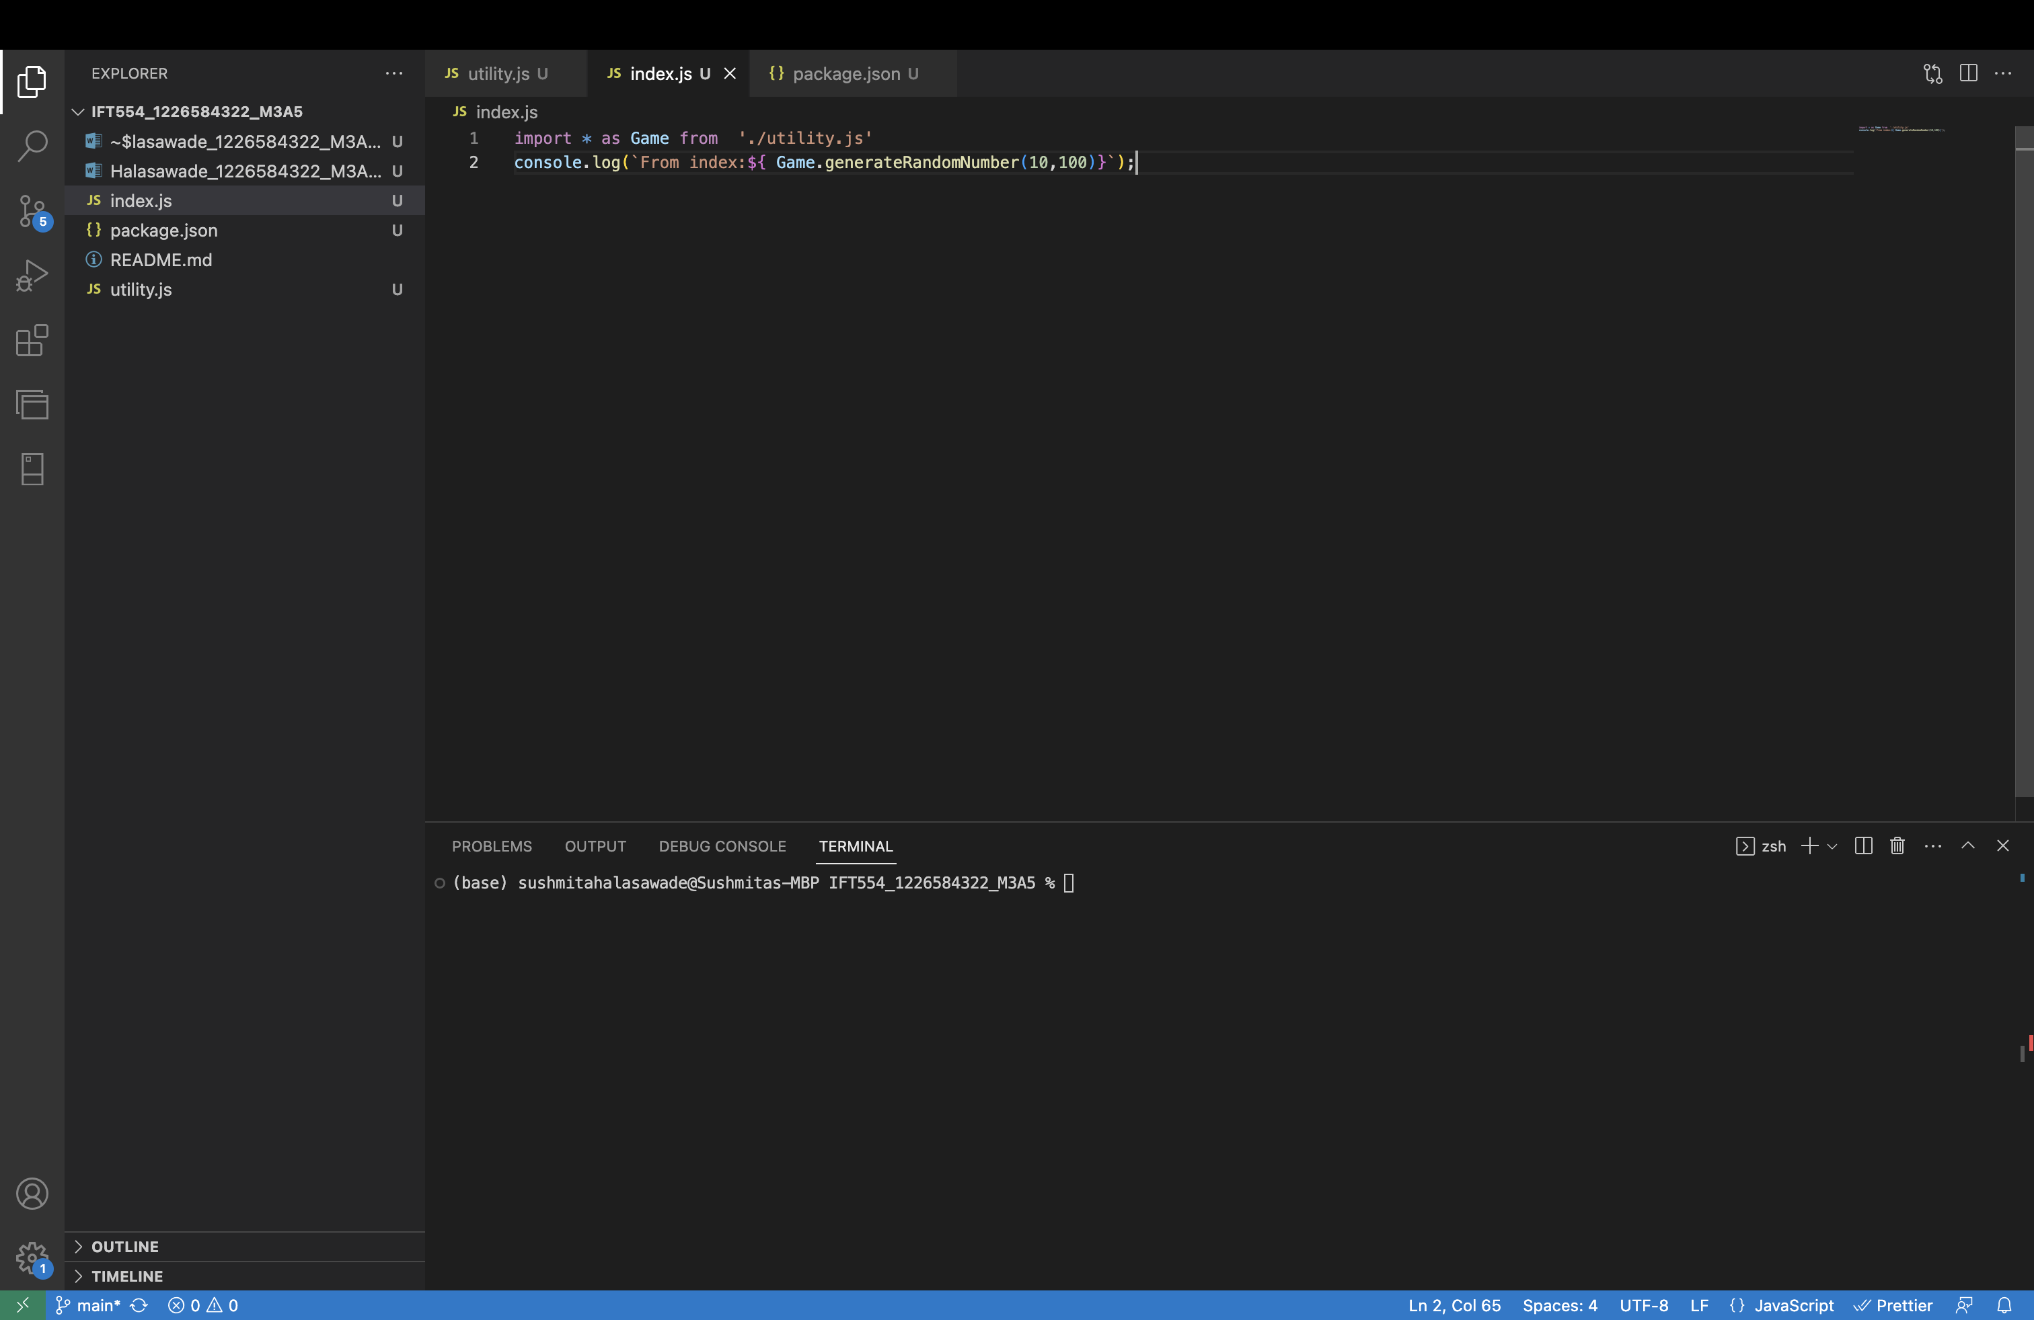

Output:

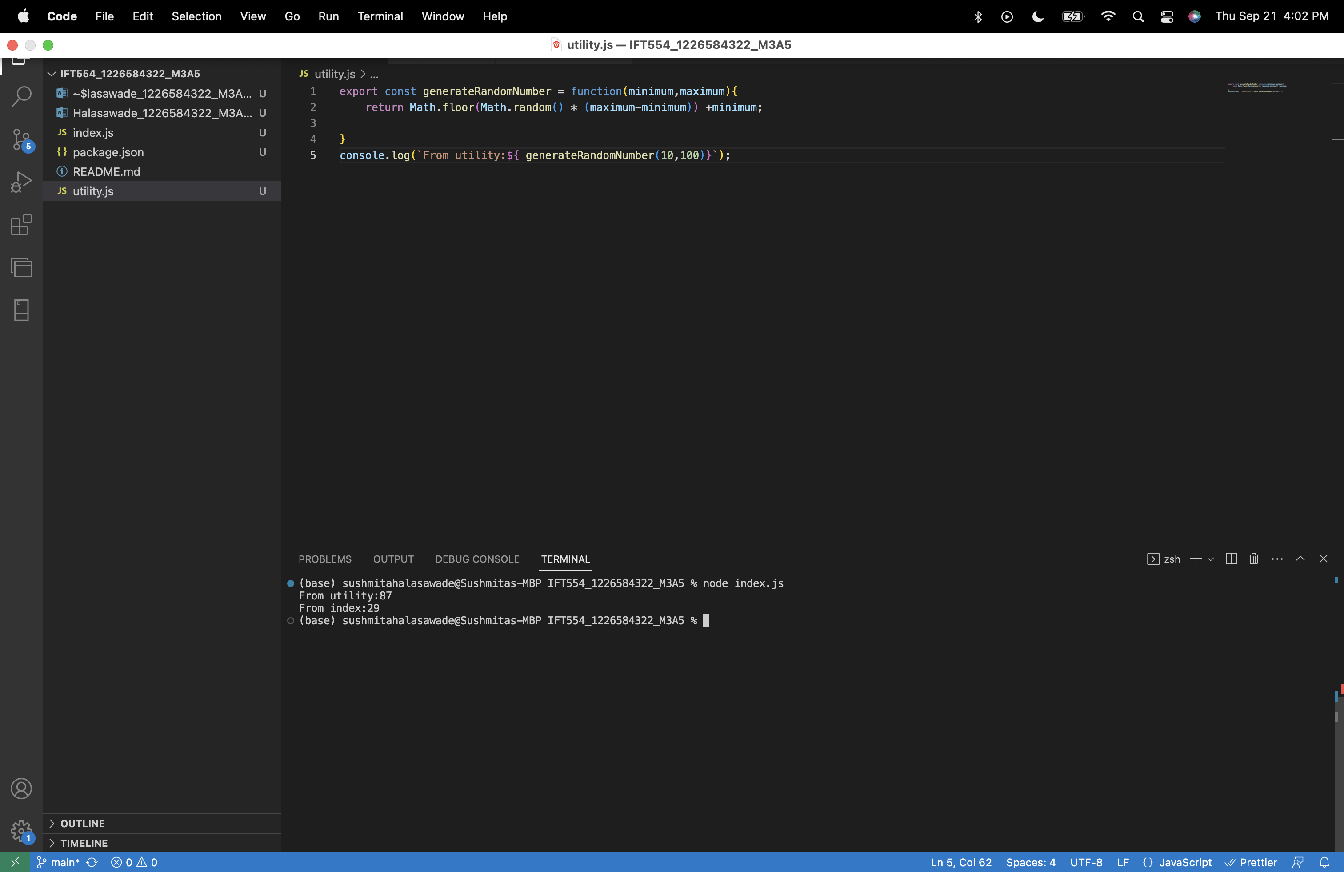

**Task 2: Using Importing External Modules (third-party modules).**

Link: <https://vpic.nhtsa.dot.gov/api/vehicles/GetModelsForMakeId/440?format=xml>

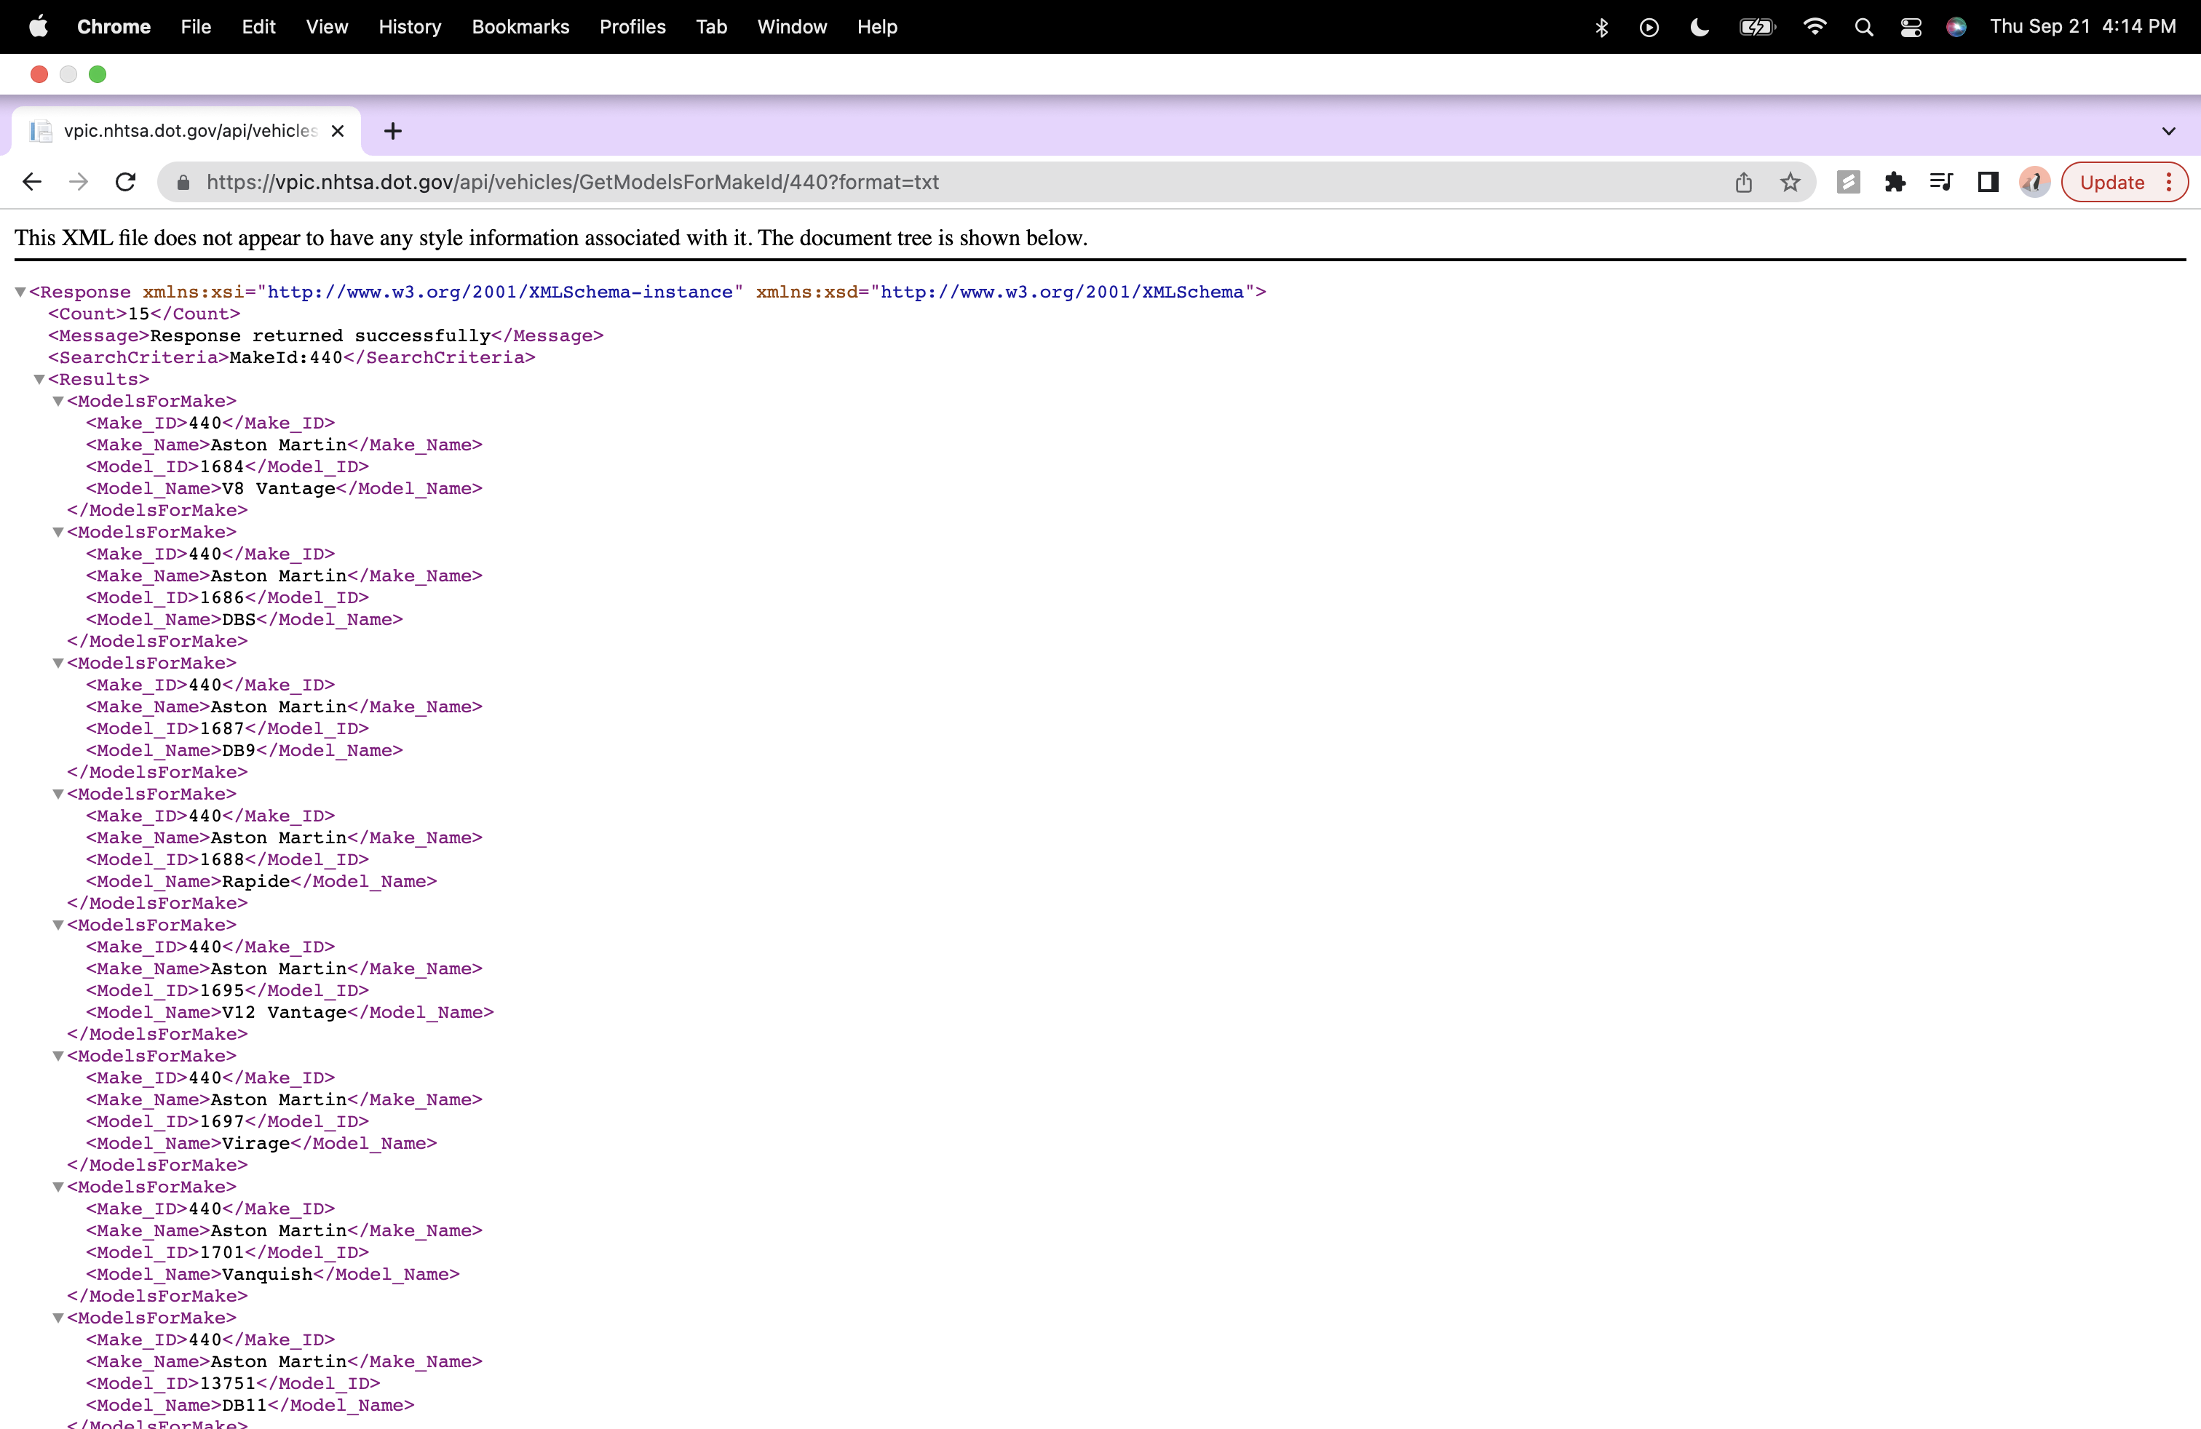

Link : <https://vpic.nhtsa.dot.gov/api/vehicles/GetModelsForMakeId/440?format=json>

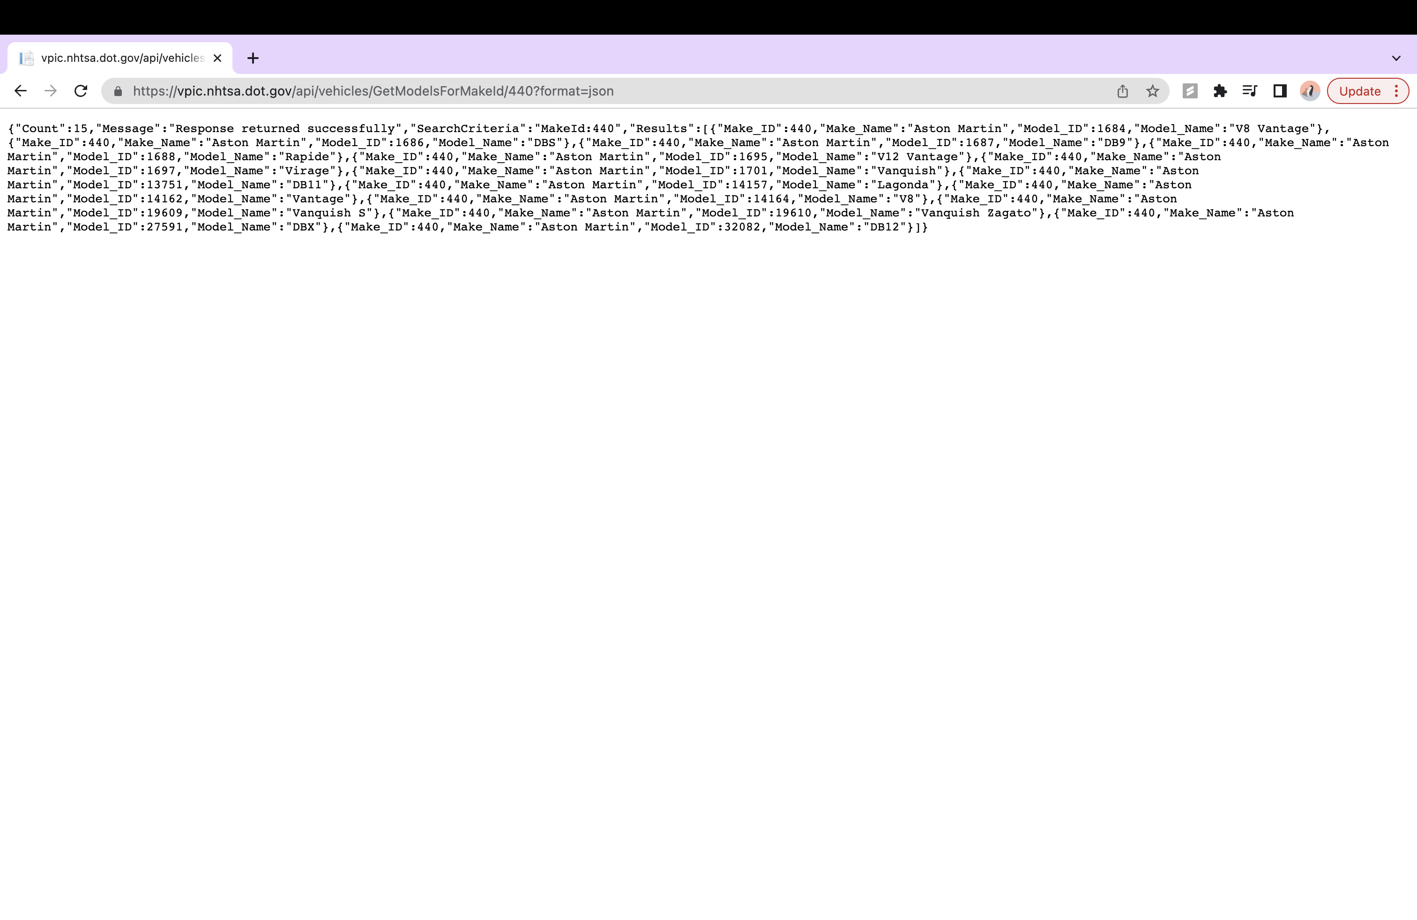

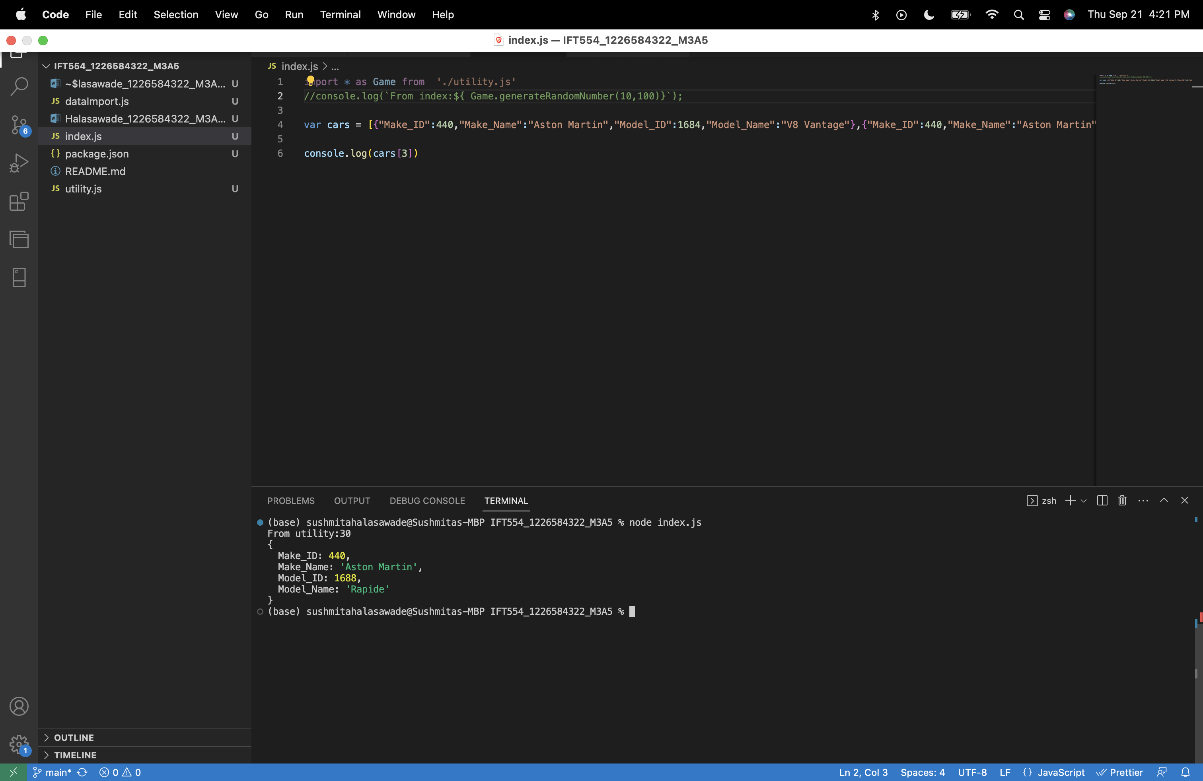

**Task 3: Data Formats and Data Exchange**

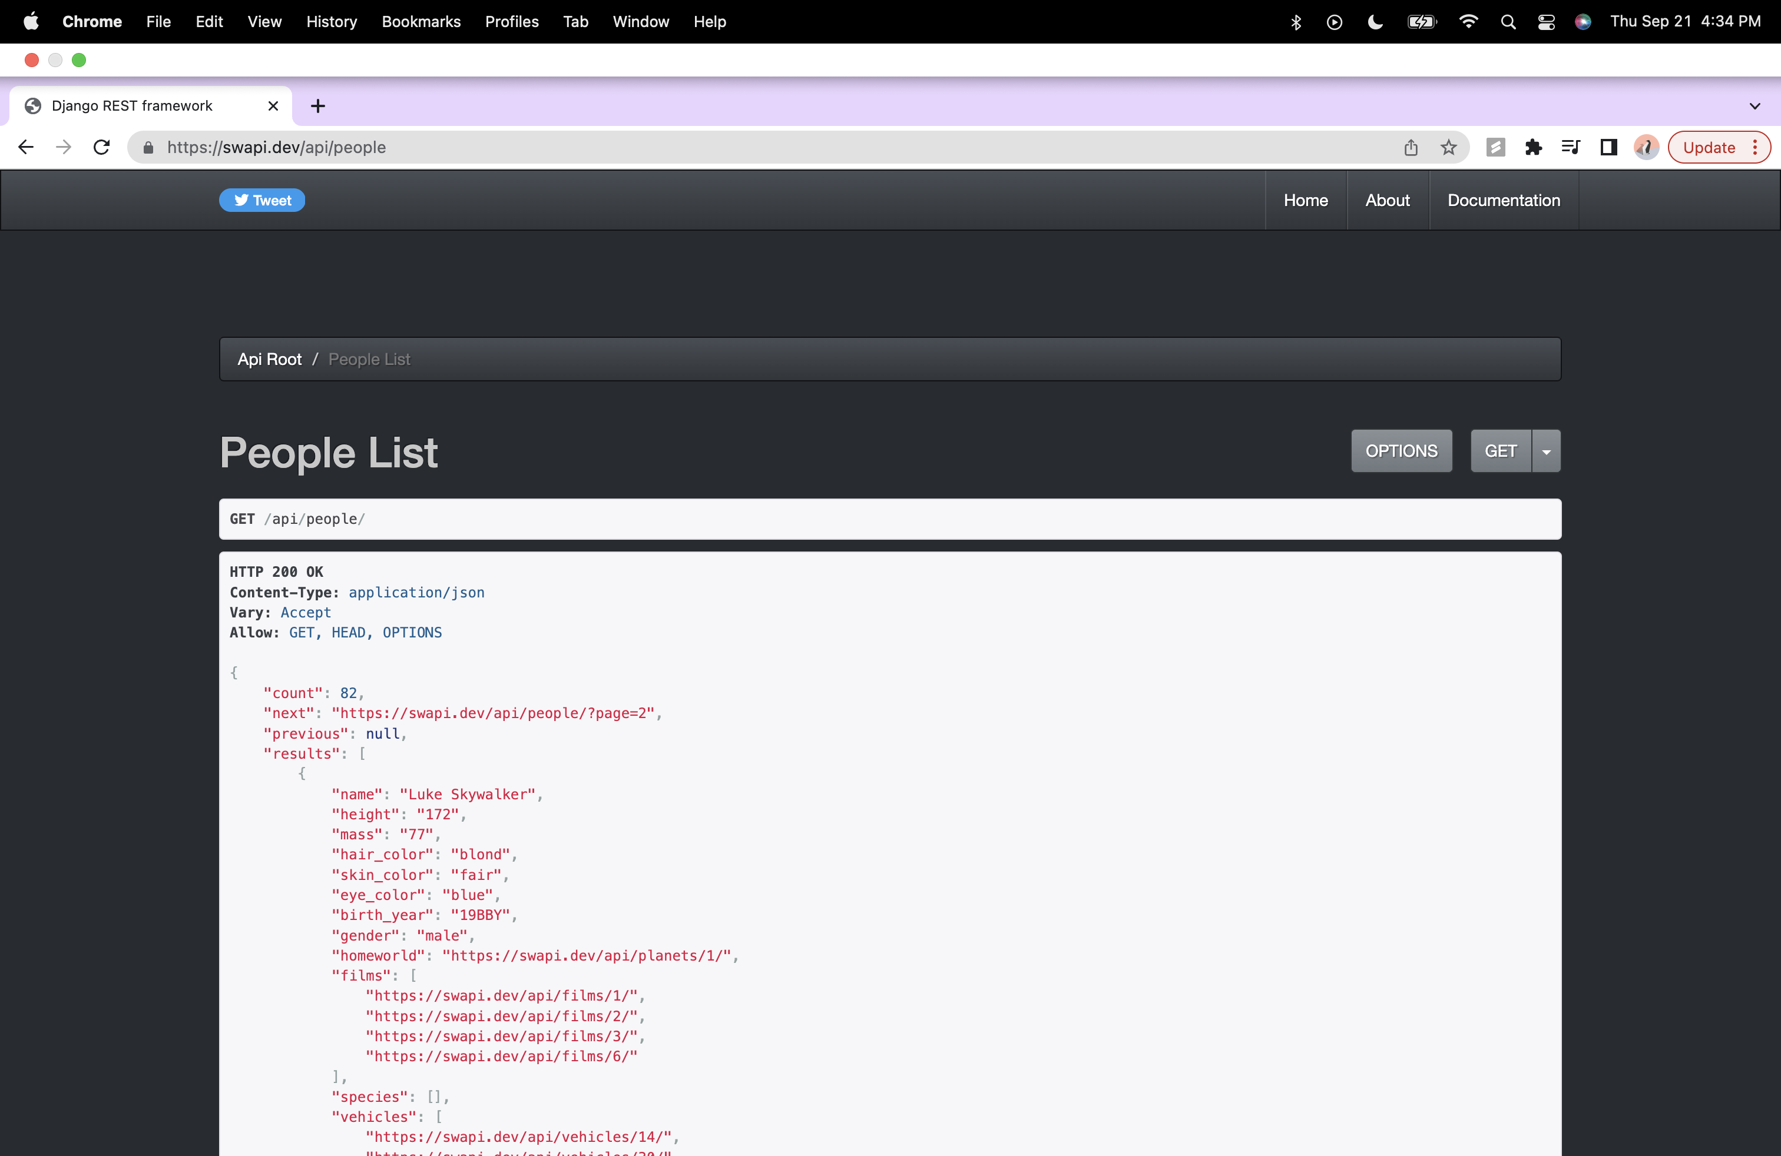

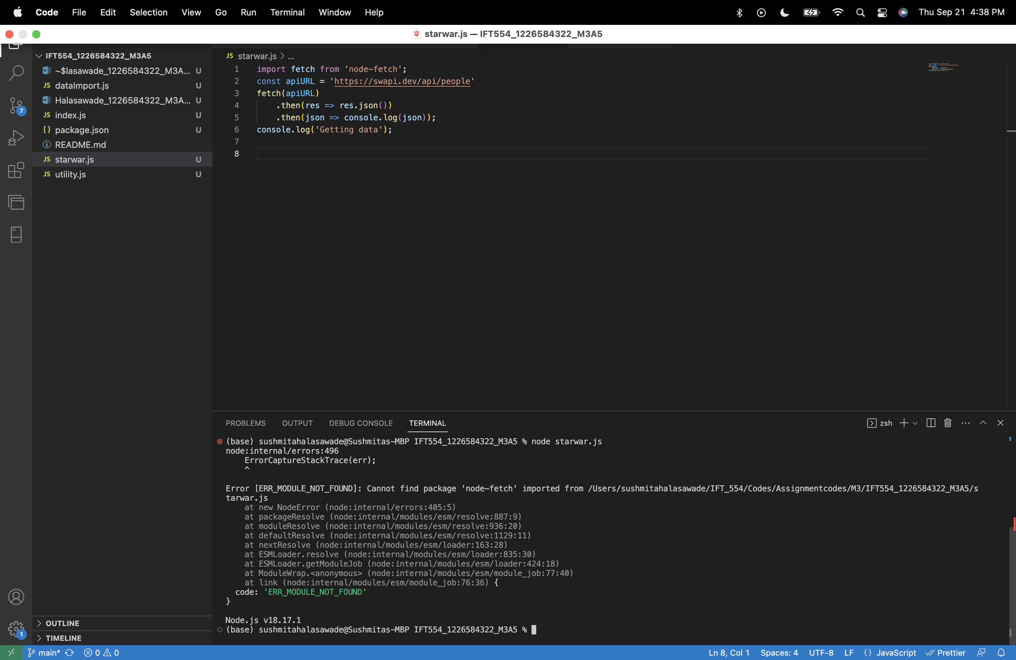

Npm install node-fetch:

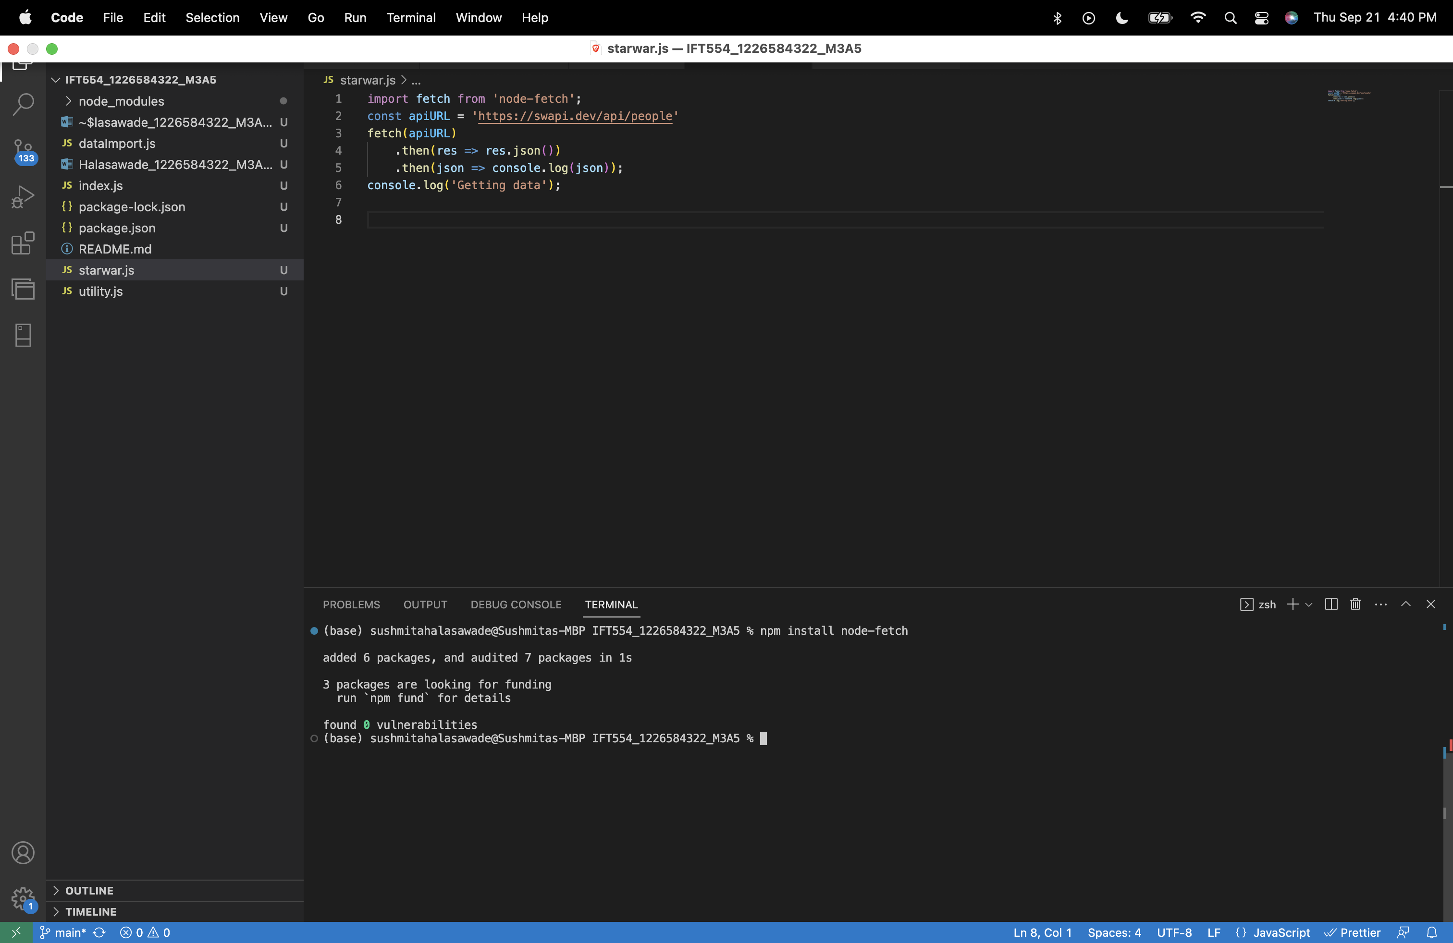

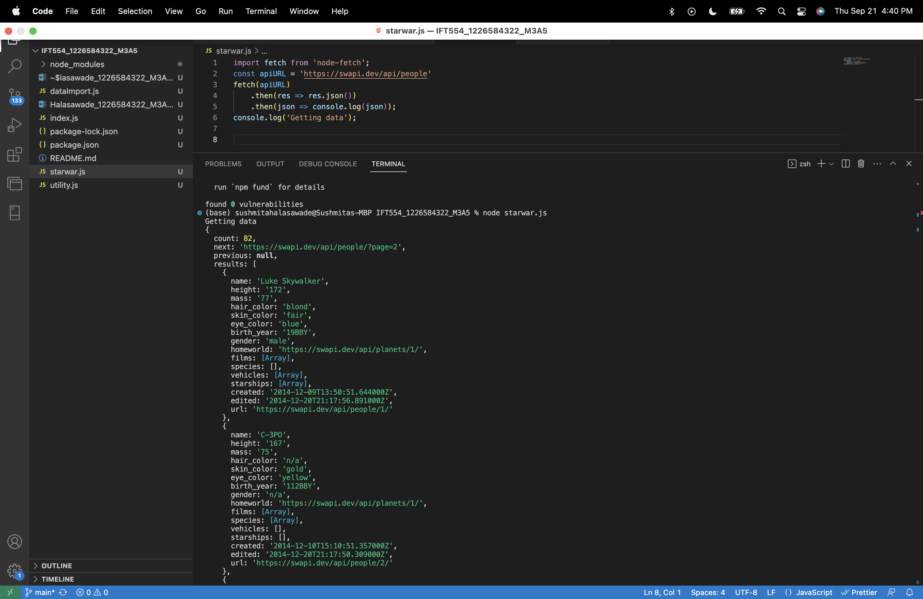

Adding success message:

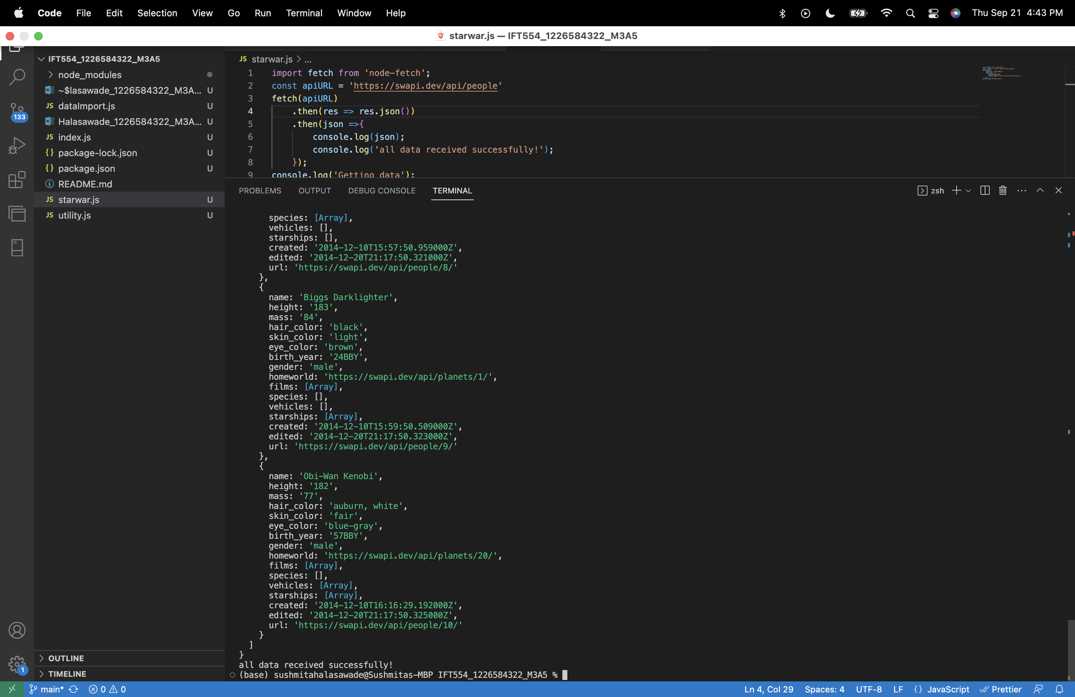

The fetch function initiates an asynchronous operation to fetch data from the API. It doesn't block the execution of the rest of the code.

While the HTTP request is being processed, JavaScript continues with the synchronous part of the code. This means that the console.log ('Getting data') statement is executed immediately after the fetch request is initiated.

When the API responds and the data is received, the callback functions inside the .then methods are added to the JavaScript event loop. They will be executed once the call stack is clear.

As a result, 'Getting data' is printed first, followed by the JSON data and the success message, which are printed once the fetch request is complete.

**Task 4: Content Negotiation**

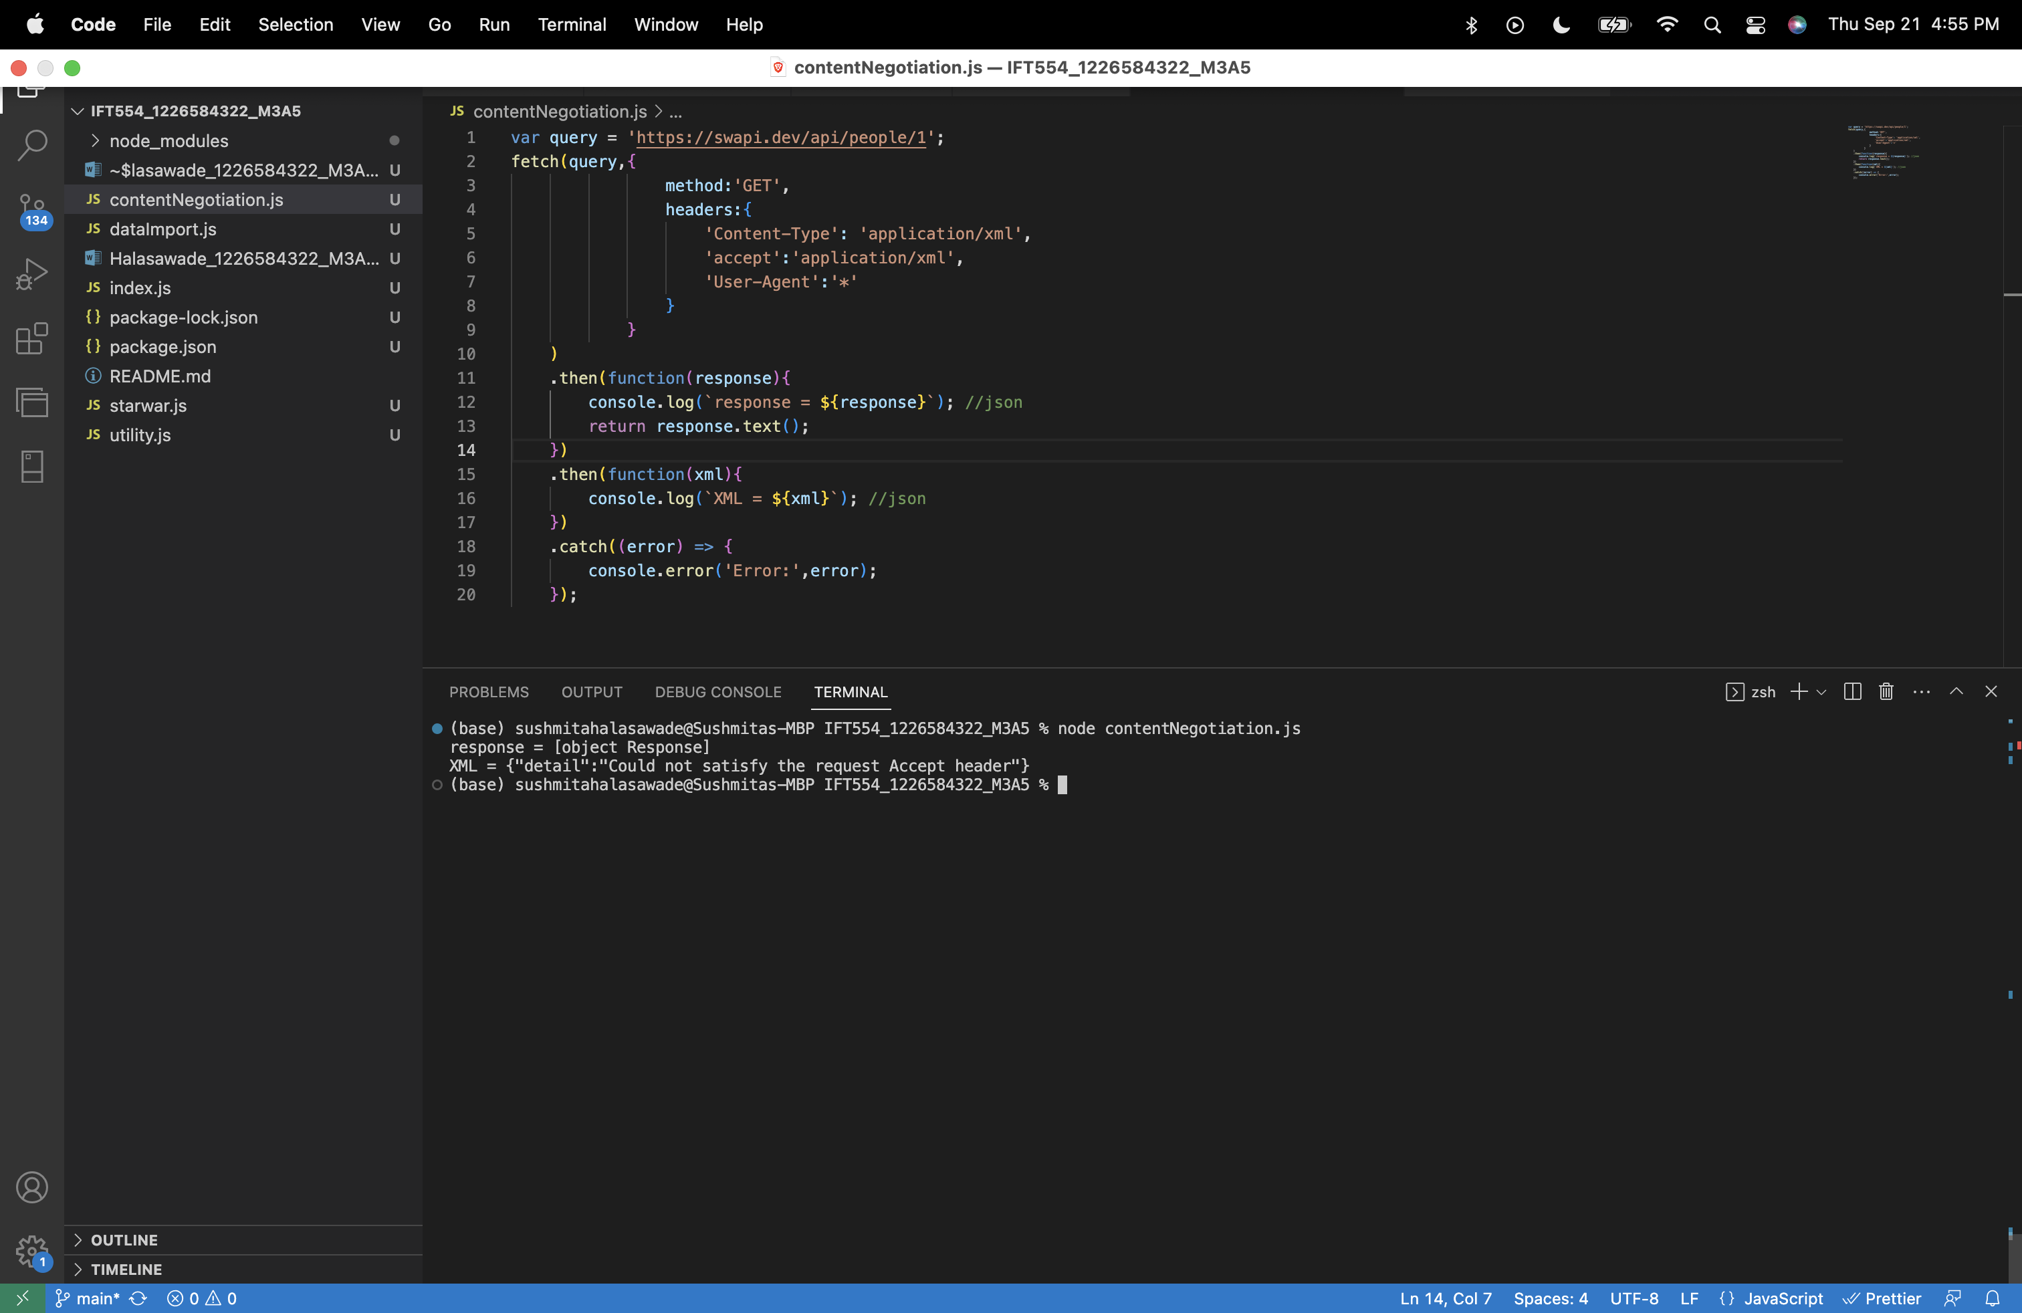

After setting accept type to json:

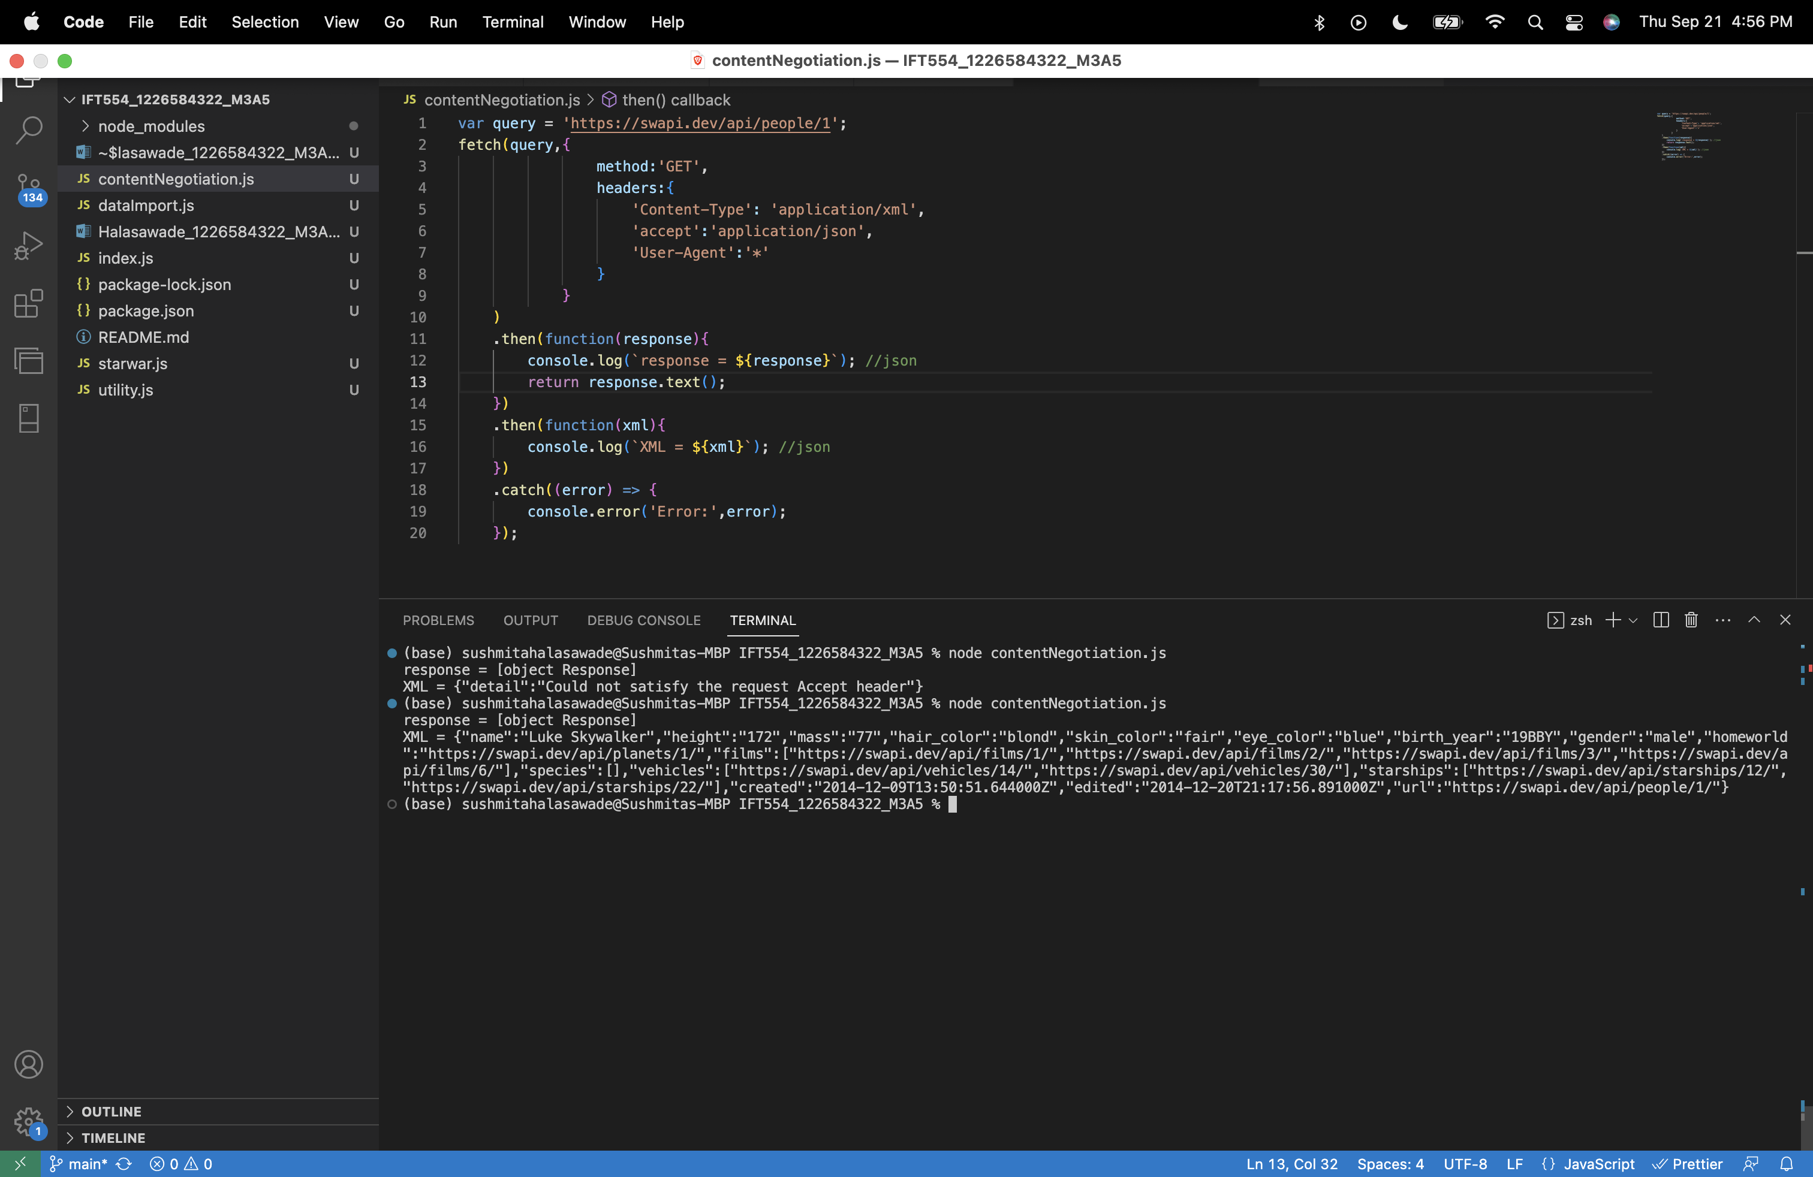

Converting json to xml using json2xml:

